Riya Chaudhary

DBMS ASSIGNMENT 8

Riya Chaudhary

17070122056

CS3

1. Write a procedure to find details of books of a given library;

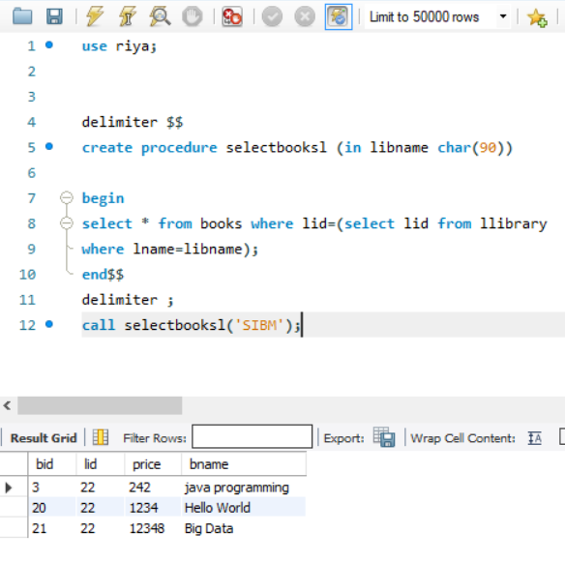  
2. Write a procedure to find out total no. of books written by a particular author.

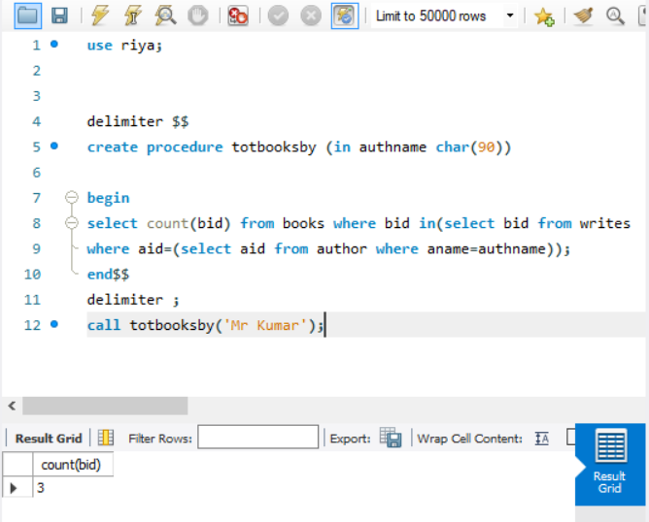  
3. Write a procedure to increase price of books by 10% which are sold by a particular seller to a particular library.

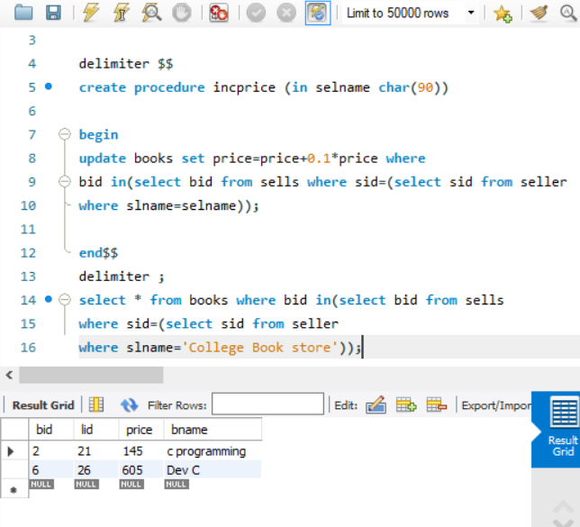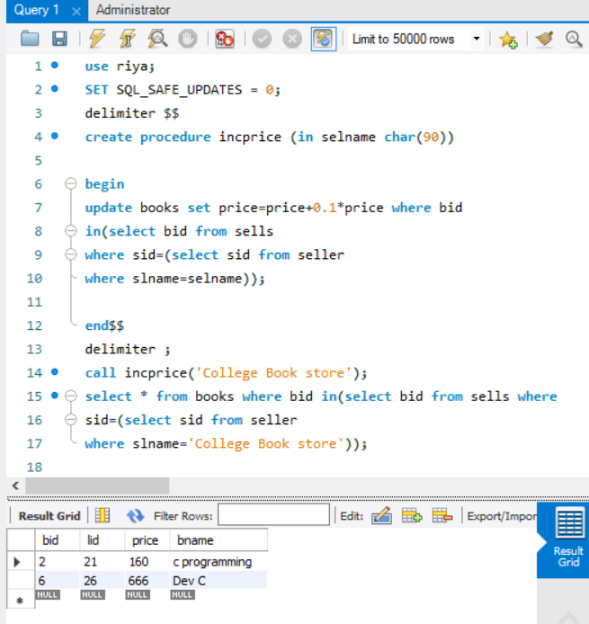  
4. Write a procedure to count total number of publishers who are providing books to a particular library.

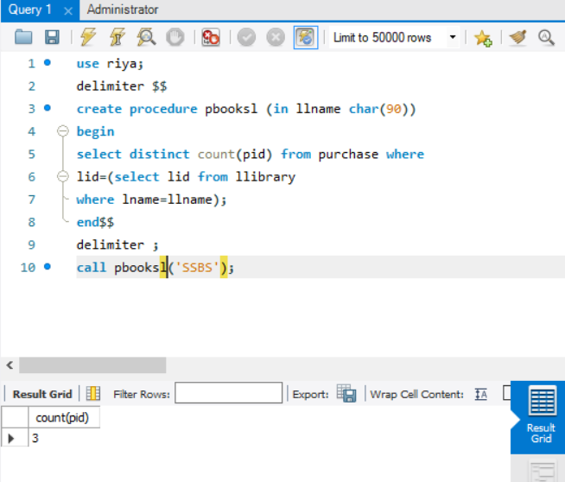  
5. Write a procedure to find the costliest and the cheapest books that a particular library has.

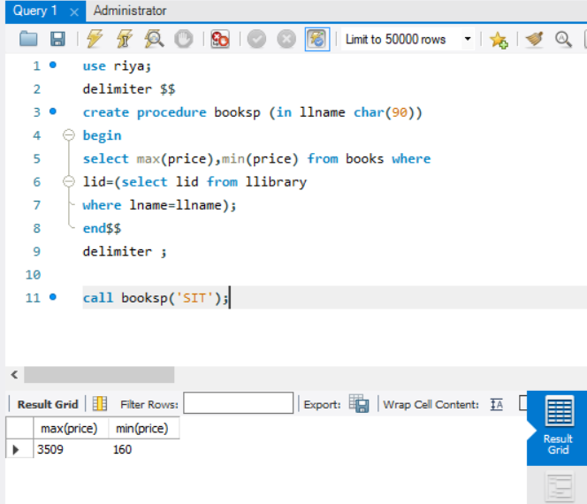  
6. Write a procedure to update the price of books by 25%, which are written by a particular author.

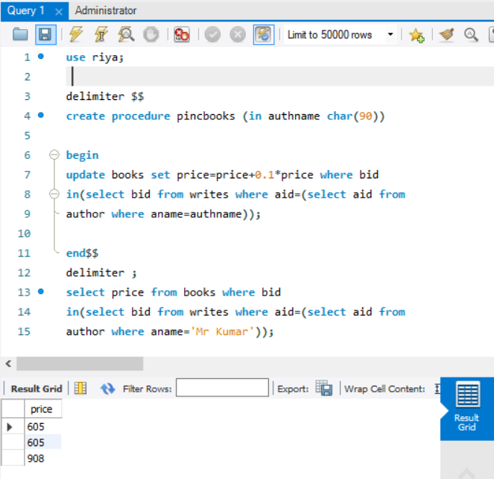

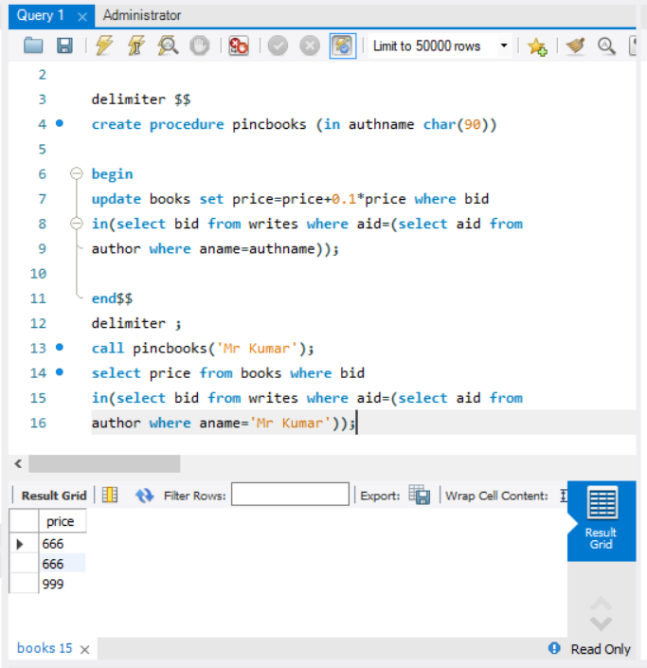  
7. Write a procedure to provide total money spent by a particular library in purchasing books in a particular month.

